SWINBURNE VIETNAM
HO CHI MINH CAMPUS


COS30018 - COS30018-Intelligent Systems
Oral Defense week 7

INSTRUCTOR: MR. KY TRUNG PHAM
STUDENT NAME: LÊ TIẾN DŨNG-SWS00683

HO CHI MINH CITY –2026

Contents
Oral Defense week 7 3
1. Describe the function you wrote to construct DL models dynamically. How does it allow you to swap between LSTM, RNN, and GRU layers without rewriting the whole training script? 3
2. What is "Multistep Prediction"? How does the output layer of your model change when you want to predict a sequence of $k$ future days instead of just tomorrow? 3
3. Explain "Multivariate Prediction." When predicting the 'Close' price, how do you structure the input array to include other time series like 'Trading Volume'? 4

Oral Defense week 7

1. Describe the function you wrote to construct DL models dynamically. How does it allow you to swap between LSTM, RNN, and GRU layers without rewriting the whole training script?
I wrote a model-builder function (build_recurrent_model) that dynamically creates a recurrent network based on parameters like layer_name (LSTM/GRU/RNN), num_layers, and units. Inside the function I map the layer_name string to the correct Keras layer class, then loop through num_layers to add recurrent layers. I set return_sequences=True for all recurrent layers except the last one so stacked RNNs work properly. Because the training pipeline stays the same, I can swap architectures by changing only MODEL_TYPE = "LSTM" to "GRU" or "RNN" without rewriting the whole training script.
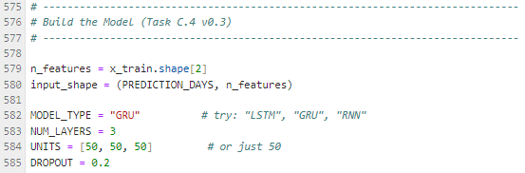

2. What is "Multistep Prediction"? How does the output layer of your model change when you want to predict a sequence of $k$ future days instead of just tomorrow?

My current implementation is single-step (Dense(1)), but multistep would require changing the label construction to sequences of length k and changing the output layer to Dense(k).
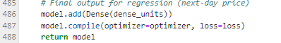

3. Explain "Multivariate Prediction." When predicting the 'Close' price, how do you structure the input array to include other time series like 'Trading Volume'?

Multivariate prediction means the model uses multiple time-series features as input while predicting a target variable such as Close. In my project, when predicting Close, each time step contains a feature vector [Open, High, Low, Close, Volume]. So the LSTM input is a 3D array shaped (samples, lookback, n_features). In my case it is (samples, 60, 5), which allows the network to learn patterns that relate price movement to volatility (High/Low) and market activity (Volume), not just Close alone.
The feature column list (multi-feature setup)

